**Create cursor for Employee table & extract the values from the table. Declare the variables ,Open the cursor & extract the values from the cursor. Close the cursor. Employee(E_id, E_name, Age, Salary)**

**-- Step 1**: Create the Employee table

CREATE TABLE Employee (

E_id INT,

E_name VARCHAR(50),

Age INT,

Salary INT

);

**-- Step 2**: Insert some sample records

INSERT INTO Employee VALUES (1, 'Alice', 30, 50000);

INSERT INTO Employee VALUES (2, 'Bob', 28, 45000);

INSERT INTO Employee VALUES (3, 'Charlie', 32, 55000);

**-- Step 3**: Now, create a procedure to use a cursor

DELIMITER //

CREATE PROCEDURE fetch_employee_details()

BEGIN

-- Declare variables

DECLARE v_id INT;

DECLARE v_name VARCHAR(50);

DECLARE v_age INT;

DECLARE v_salary INT;

DECLARE done INT DEFAULT 0; -- flag to indicate end of data

-- Declare the cursor

DECLARE emp_cursor CURSOR FOR

SELECT E_id, E_name, Age, Salary FROM Employee;

-- Declare NOT FOUND handler

DECLARE CONTINUE HANDLER FOR NOT FOUND SET done = 1;

-- Open the cursor

OPEN emp_cursor;

-- Start fetching loop

emp_loop: LOOP

FETCH emp_cursor INTO v_id, v_name, v_age, v_salary;

IF done THEN

LEAVE emp_loop;

END IF;

-- Print the extracted values

SELECT

CONCAT('ID: ', v_id, ', Name: ', v_name, ', Age: ', v_age, ', Salary: ', v_salary)

AS Employee_Info;

END LOOP emp_loop;

-- Close the cursor

CLOSE emp_cursor;

END //

DELIMITER ;

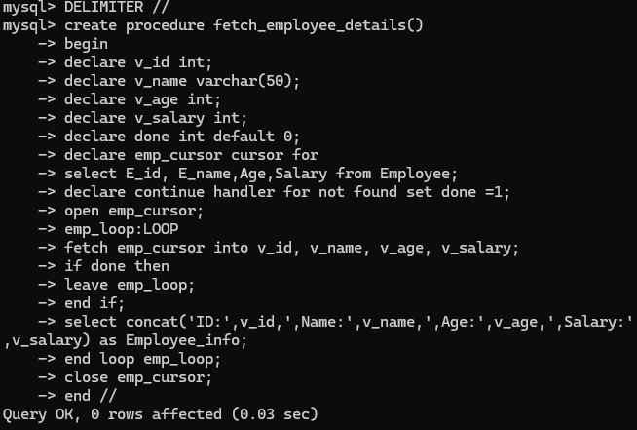

**-- Step 4**: Call the procedure

CALL fetch_employee_details();

